

GOOGLE PROJECT MANAGEMENT TRACK

GRADUATION PROJECT



Table of Contents

**Track Overview** 2

**Our graduation project Scope & Objective** 2

**Project Management Pioneers (The team) Policy** 2

**Problem # (3) Statement** 4

**Problem # (3) Effect** 4

**Problem # (3) Impact** 4

**Project Initiating & Define Phase** 5

Problem # (3) Project Charter 5

Problem # (3) Stakeholder Register 8

Problem # (3) RACI Matrix 9

Problem # (3) SIPOC 9

**Measure Phase for the project** 10

Problem # (3) Data Collection 10

Problem # (3) Data Analysis & Visualization 11

**Analysis Phase for the project** 13

Problem # (3) Fishbone Diagram 13

Problem # (3) SWOT Analysis 13

Problem # (3) FlowChart for Process 14

Problem # (3) Activity List 15

Problem # (3) Activity Diagram 15

**Improve Phase for the project** 16

Problem # (3) Theory of constraints 16

Problem # (3) Gantt Chart 16

Problem # (3) Network Diagram 17

Problem # (3) Work Breakdown Structure 18

Problem # (3) Objectives and Key Results (OKRs) 19

**Control & Closing Phase for the project** 19

Problem # (3) Setting Metrics & KPIs 19

Problem # (3) Closing Project 20

# **Track Overview**

| Inquiry | Details |
| --- | --- |
| Round Number | 1 |
| Track Name | Google Project Management |
| Instructor's Name | Dr. Haitham Salem |
| WhatsApp Group Code | NEXT73 _CAI1_ERP8_M1e |
| Provider | Next Academy |
| Number of Project Group Members | 5 |
| Project Group Name | Project Management Pioneers |

# **Our graduation project Scope & Objective**

* The graduation project scope includes applying project management principles according to what we learned during the educational course, based on the required tasks.
* According to the Project Management Pioneers team, the graduation project Objective includes:

1. Group training on the use of the tools we studied to improve the Learning Curve by at least 5%.
2. Experience sharing among the team.
3. Collaboration and teamwork.
4. Brainstorming for problem-solving methods.

# **Project Management Pioneers (The team) Policy**

* On September 7, 2024, the team created a WhatsApp group to collaborate on the project. One team member was chosen as the leader and project manager. The following rules were agreed upon to achieve the goals of the Project Management Pioneers team:

1. Each team member selected a project idea and presented it in an online meeting to the rest of the team.
2. The team chose the best idea to apply and implement for their graduation project.
3. The team agreed that each member would complete their assigned tasks individually, then discuss their work together to reach the best results, make improvements, and finalize the project.

* Four different ideas were generated, and the team evaluated them to choose the best one using several factors based on the educational background and experiences of all team members, such as the simplicity of the idea, the general understanding of the problem by all team members, and the team's ability to provide the required data based on their professional experience or assumptions. The ideas included:

1. An idea for developing a system for patient discharge from hospitals after completing procedures. (Idea Number 1).
2. A hypothetical idea for reducing production waste on one of the production lines. (Idea Number 2).
3. A realistic idea concerning the issue of reducing the average delivery times (The Lead Time LT) of products to customers. (Idea Number 3).
4. A realistic idea concerning the issue of improving the performance of the fleet and logistics. (Idea Number 4).

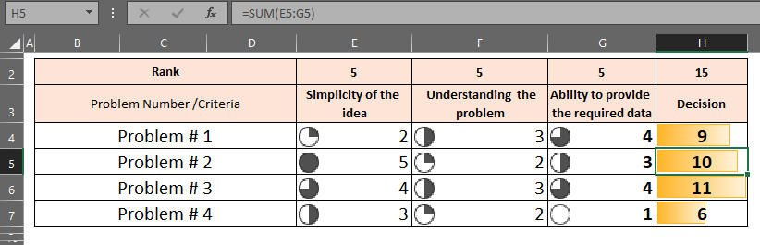

The team selected problem number 3 to study and apply project management concepts through the required tasks and present it to the initiative management.

# **Problem # (3) Statement**

A leading lighting company in Egypt is facing a problem due to the long delivery time (lead time) for products to customers.

Currently, the delivery time from the moment a customer places an order is between 25 to 28 days on average, which is much longer than the company's policy that states the delivery time should not exceed 10 to 15 days.

# **Problem # (3) Effect**

The long delivery time has caused delays in fulfilling customer orders, leading to a buildup of pending orders.

As a result, the sales department is struggling to accept new orders from other customers due to the delivery delays, especially for export orders outside Egypt.

This situation negatively affects customer satisfaction and prevents the company from achieving its sales targets.

# **Problem # (3) Impact**

Due to the company's clear policies requiring adherence to a specific lead time, the gap between the actual and planned delivery times has affected various levels:

* Strategic level: The company is unable to expand and grow, especially in foreign markets, because it cannot meet customer needs on time. This also affects the ability of those customers to serve their own clients.
* Tactical level: The factory struggles to manage changing priorities set by the sales department, making it difficult to maintain the minimum needed to keep customers satisfied and ensure long-term relationships.
* Operational level: Daily production and labor activities are disrupted due to constantly shifting priorities, making it harder for the operations manager to plan effectively.

# **Project Initiating & Define Phase**

## Problem # (3) Project Charter

| 1 | General Project Information | |
| --- | --- | --- |
| Project Name | | Reducing the average delivery times (The Lead Time LT) of products to customers |
| Executive Sponsors | | Digital Egypt Pioneers Grant Management.  Ministry of Communications.  Next Academy.  Dr. Haitham Salem (Instructor). |
| Department Sponsor | | Project Management Pioneers team leader |
| Project Impact | | The team expects that by the end of the project, the company will be able to:  Achieve strategic objectives by expanding outside Egypt through the ability to meet all customer needs from abroad.  Achieve medium-term goals within the company by managing priorities and changing those priorities in coordination with production management to meet the fluctuations in sales requests.  Achieve daily objectives by ensuring continuity of operations without interruption. |

| 2 | Project Team | | | |
| --- | --- | --- | --- | --- |
| Project Manager Name | | Department | Phone | Email |
| Yousef Mohamed | | Team Leader | 01026041908 | [Engyousef55@yahoo.com](mailto:Engyousef55@yahoo.com) |
| Team Member Names | | Department | Phone | Email |
| Ahmed Tarek Ahmed | | Team Member | 01006110828 | [ahmed.tarek.0110@gmail.com](mailto:ahmed.tarek.0110@gmail.com) |
| Abdelhamid Tarek Mohamed | | Team Member | 01140312811 | [abdalhamidtarek@gmail.com](mailto:abdalhamidtarek@gmail.com) |
| Fatima Hassan | | Team Member | 01114856493 | [fatmaabdelaziz1442002@gmail.com](mailto:fatmaabdelaziz1442002@gmail.com) |
| Hajar Elfekey | | Team Member | 01003393111 | [hajaralfeqi@gmail.com](mailto:hajaralfeqi@gmail.com) |

| 3 | Stakeholders |
| --- | --- |
| Stakeholders including   * Company Owners. * Sales Management. * The Factory or Company. * Digital Egypt Pioneers Initiative Management. | |

| 4 | Project Scope | |
| --- | --- | --- |
| Project Purpose / Business Justification | | The implementation of this project will support the requirement of the Stakeholders   * Sales Management: The department with the desire to achieve sales objectives. * Company Owners: The owners of the company who are responsible for expansion and growth plans. * The Factory or Company: The entity responsible for implementing the owners' plans. * Digital Egypt Pioneers Initiative Management: The management concerned with the success of the graduation project. |
| Objectives | | The objective is to reduce the delivery time to comply with the company's policy, ensuring that the delivery time does not exceed 10 to 15 days, instead of the current duration of 25 to 28 days. |
| Deliverables | | Meeting the actual sales needs represented by 3 sales sources, which are:   * External sales * Internal sales * Safety stock balances |
| Within Scope | | The factory will work on meeting the actual needs of all types of sales (export sales, local sales, or maintaining stock balances within the company) in a way that ensures achieving the company's goal of expansion by reducing delivery time to 10 to 15 days. |
| Outside of Scope | | The factory and the project's outcomes are not responsible for any sales requirements that fall outside the scope of the agreed budget at the beginning of the year. These requirements include any products being developed from design to delivery. The project only covers the products currently available in the existing catalog. |
| Project Milestones | | * Project Team * Finalize Project Plan , Project Charter * Define Phase * Measurement Phase * Analysis Phase * Improvement Phase * Control Phase * Project Summary Report and Close Out |
| Risks | | The risks in the project include senior management's desire, represented by decision-makers, to accept or make exceptions for other projects, even if they are smaller in scale, but outside the project's scope. |
| Constraints | | The expected or assumed constraints primarily include the human resources that may be required to carry out any fieldwork within the factory, as well as the potential shortage of workers if part of the workforce is allocated to follow up on the project within the factory. |
| Assumptions | | We assume that the sales requirements fall within the framework previously agreed upon in the annual budget for the factory's capacities. |

| 5 | Communication Strategy |
| --- | --- |
| The communication methods include the following:   * Phone calls as needed * Email correspondence as needed * Regular meetings for managers and stakeholders, with daily meetings for lower management levels and weekly meetings for higher management. | |

| 6 | Notes |
| --- | --- |
| Final Customer of the Project   * **Internal Customer**: Sales Management in the Company * **External Customer**: Agents in Foreign Countries   **Expected Benefits**   * Reduce delivery time to 10 to 15 days instead of the current duration of 25 to 28 days. * Achieve the company's vision for expansion and growth. | |

| 7 | Sign-Off | | | |
| --- | --- | --- | --- | --- |
| Role | | Name | Signature | Date |
| Sponsor | | Digital Egypt Pioneers Grant Management. |  |  |
| Sponsor | | Ministry of Communication |  |  |
| Sponsor | | Next Academy & Dr. Haitham |  |  |
| Team Leader | | Project Management Team Leader |  |  |
| Sales Manager | | Sales Manager |  |  |

## Problem # (3) Stakeholder Register

| 7 | Stakeholder Register, 00/00/0000 | | | | | |
| --- | --- | --- | --- | --- | --- | --- |
| Role | | Name | Contact Information | Requirement | Expectation | Class |
| Stakeholder | | Digital Egypt Pioneers Grant Management. | 000-00-0000 | Providing the appropriate environment for students and graduates to start their own businesses on freelancing platforms. | Building and empowering Egyptian youth to enhance their global competitiveness through a comprehensive program aimed at preparing them for freelancing and acquiring the digital skills required in the modern job market. | Friend /High Level |
| Stakeholder | | Ministry of Communication | 000-00-0000 |
| Stakeholder | | Next Academy & Dr. Haitham | 000-00-0000 |
| Stakeholder | | Company Owner | 000-00-0000 | Avoiding any work stoppage for reasons related to project implementation, if possible. | Achieving the company's goal of expansion and meeting sales needs. |

## Problem # (3) RACI Matrix

| Task | Project Management Pioneer team | Stakeholders | Sales team |
| --- | --- | --- | --- |
| Setting up the graduation Project | R | C | I |
| Setting up the tools we have studied | R | C | I |
| Reduce the Lead time | A | C | I |

## Problem # (3) SIPOC

| Process Function | SIPOC for the Lead time Problem Analysis | | Date | 0000/00/00 |
| --- | --- | --- | --- | --- |
| Scope | Create an action plan to be a reference used in process analysis. | | | |
| S | I | P | O | C |
| Supplier | Input | Process | Output | Customer |
| Sales team | Confirmed Orders | Gathering and Analyzing Sales Orders. | Demand Pattern & Demand Plan. | Demand Planner. |
| Studying the Resources Needed to Manufacture Sales Orders. | Net Requirement report to fit the plan. | Warehousing team. |
| Calculating the Total Time Required to Manufacture Sales Orders and Comparing it to the Target Time. | Actual net requirement plan. | Procurement team. |
| Studying the Root Causes of Any Gaps Found. | Root cause analysis report. | Industrial Engineers teams. |
| Working on Performance Improvement Through Designated Tools to Achieve the Target Manufacturing Time. | Action plan to overcome the gap. | All involved in this project. |
| Working to Sustain Results and Measure Performance. | Sustain Results based on data. | All involved in this project. |

# **Measure Phase for the project**

## Problem # (3) Data Collection

Over the past six months, a concerning and disproportionate increase in lead time has been observed compared to the internally agreed-upon duration within the company. This data has been recorded as follows:

| Month # | Week # | Total Order received | Perfect Orders | Missed Orders | Actual Lead time (Days) |
| --- | --- | --- | --- | --- | --- |
| 1 | 1 | 18 | 15 | 3 | 28 |
| 2 | 15 | 15 | 0 | 25 |
| 3 | 14 | 10 | 4 | 26 |
| 4 | 16 | 13 | 3 | 24 |
| 2 | 1 | 10 | 8 | 2 | 25 |
| 2 | 12 | 9 | 3 | 26 |
| 3 | 18 | 16 | 2 | 28 |
| 4 | 22 | 18 | 4 | 29 |
| 3 | 1 | 23 | 20 | 3 | 27 |
| 2 | 20 | 15 | 5 | 20 |
| 3 | 18 | 17 | 1 | 20 |
| 4 | 12 | 9 | 3 | 26 |
| 4 | 1 | 10 | 6 | 4 | 24 |
| 2 | 15 | 10 | 5 | 22 |
| 3 | 18 | 14 | 4 | 28 |
| 4 | 16 | 15 | 1 | 27 |
| 5 | 1 | 14 | 12 | 2 | 24 |
| 2 | 15 | 13 | 2 | 28 |
| 3 | 13 | 10 | 3 | 26 |
| 4 | 11 | 8 | 3 | 27 |
| 6 | 1 | 11 | 7 | 4 | 25 |
| 2 | 16 | 14 | 2 | 28 |
| 3 | 17 | 15 | 2 | 29 |
| 4 | 16 | 12 | 4 | 29 |

## Problem # (3) Data Analysis & Visualization

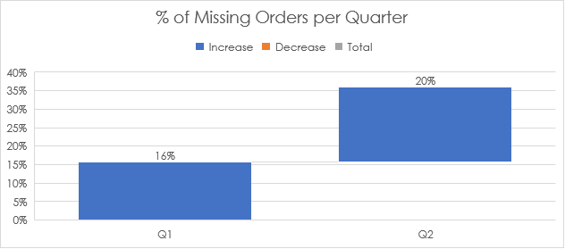

We find that the percentage of unfulfilled orders has increased from 16% to 20% during the period from the first quarter to the second quarter. Therefore, it is essential to investigate the root causes that lead to this issue.

Similarly, we observe an increase in the average lead time from the first quarter to the second quarter, rising from 25.3 days to 26.4 days.

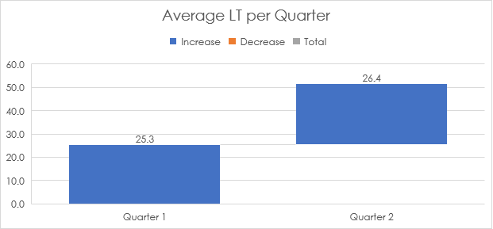

# **Analysis Phase for the project**

Based on the analysis of the factory's data, we find an increase in the average lead times. It is essential to investigate the root causes of such issues and the reasons for the deviations from the agreed-upon time. (25 to 28 days VS 10 to 15 days).

## Problem # (3) Fishbone Diagram

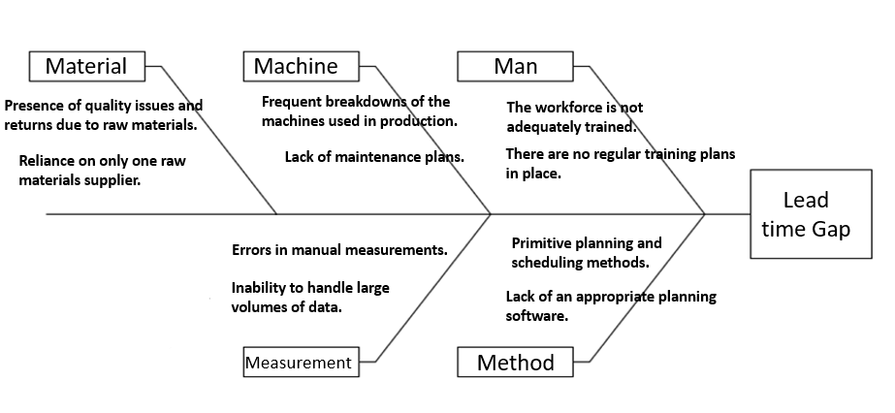

Then, strengths, weaknesses, opportunities, and threats will be analyzed using a SWOT analysis to integrate the results with the outputs of the fishbone diagram. This will allow us to map the process flow and study the work time for each operation.

## Problem # (3) SWOT Analysis

| INTERNAL FACTORS | |
| --- | --- |
| STRENGTHS + | WEAKNESSES – |
| The company's vision regarding expansion and growth.  A clear vision from the company concerning delivery times.  Stakeholders' agreement on a common goal regarding delivery times. | The resources available at the factory may not be sufficient to meet sales needs.  If the factory halts any process, it will lead to conflicts of interest among stakeholders. |
|  |  |
| EXTERNAL FACTORS | |
| OPPORTUNITIES + | THREATS – |
| There are opportunities for external expansion and growth through exports.  Partners may provide additional investments for expansion and growth. | If external agents request additional unplanned products, the factory may face difficulties in meeting those needs at the moment. |
|  |  |

Then, the steps and flow of processes are studied.

## Problem # (3) Flow Chart for Process

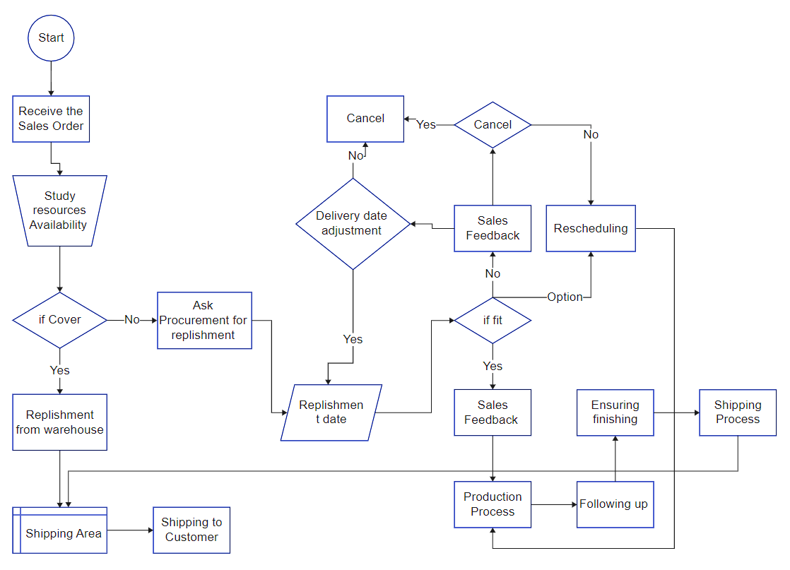

## Problem # (3) Activity List

Based on the outputs of the previous tools, a list of activities necessary to meet sales needs can be created and prepared according to the process flow.

| Activity List | | | | |
| --- | --- | --- | --- | --- |
| Project Title /Scope | | Reducing the LT | | |
| ID | Activity | | Pre.ID | Description |
| A | Receiving Sales Order | | - | The process to receive sales requirement |
| B | Studying Sales Order | | A | The process to check our resources (SKU) |
| C | Internal Planning Process for Sales Order | | B | The process to MRP, PP, Inventory Planning, Due dates, etc. |
| D | External Planning for operating Sales Order | | B | The process for the procurement process |
| E | Scheduling Sales Order | | D | Production line Scheduling |
| F | Following up Sales Order | | E | Following up during the previous process |
| G | Shipping Sales Order | | C, F | Shipping to the customer |
| H | Feedback | | G | Receiving feedback and closing loop |

## Problem # (3) Activity Diagram

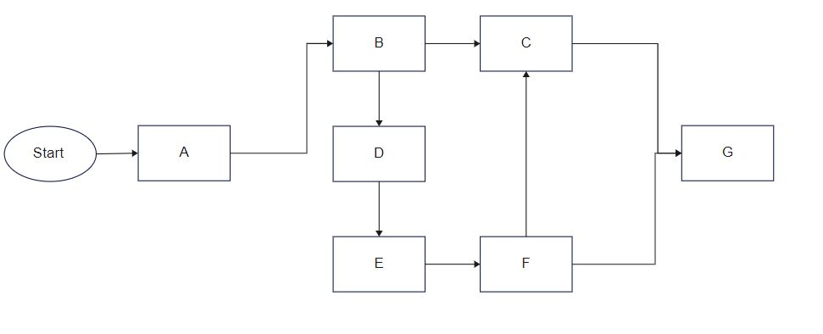

# **Improve Phase for the project**

At this stage, we will develop some tools and methods through which performance can be improved to reduce lead time.

## Problem # (3) Theory of constrain

The constraints present in the factory, which affect the outputs of the fishbone diagram in two problems—maintenance and labor training shortage—will be applied.

For the maintenance & training issue, the factory does not object to conducting regular maintenance & training for a period of 2 weeks, with one day each week, to align with the factory's scheduling and operational plans. The maintenance plan will be as follows:

| Maintenance & Training Plan | | | | | |
| --- | --- | --- | --- | --- | --- |
| Week | Day | Day (State) | Maintenance State | Training State | Notes |
| 1 | Saturday | Day off |  |  |  |
| 1 | Sunday | Working Day | ✔ |  |  |
| 1 | Monday | Working Day |  | ✔ |  |
| 1 | Tuesday | Working Day |  |  |  |
| 1 | Wednesday | Working Day | ✔ |  |  |
| 1 | Thursday | Working Day |  | ✔ |  |
| 1 | Friday | Day off |  |  |  |
| 2 | Saturday | Day off |  |  |  |
| 2 | Sunday | Working Day |  |  |  |
| 2 | Monday | Working Day | ✔ |  |  |
| 2 | Tuesday | Working Day |  |  |  |
| 2 | Wednesday | Working Day |  |  |  |
| 2 | Thursday | Working Day | ✔ | ✔ |  |
| 2 | Friday | Day off |  |  |  |

## Problem # (3) Gantt Chart

For visual representation, a specialized software program is used to draw the activity diagram.

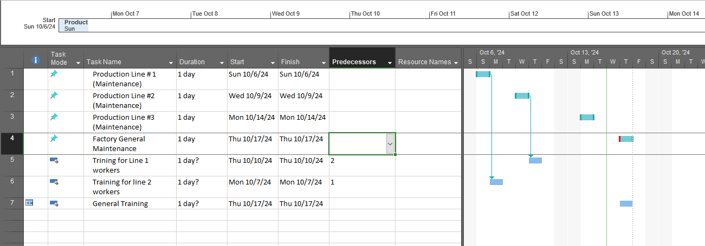

## Problem # (3) Net Work Diagram

For visual representation, a specialized software program is used to draw the Network diagram.

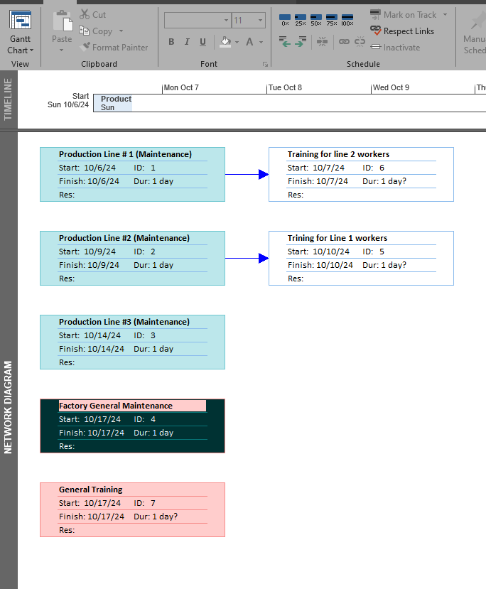

## Problem # (3) Work Breakdown Structure

For visual representation, we use the WBS (Work Breakdown Structure) to illustrate the detailed process for Maintenance & Training Plan



**Maintenance for Production Line 1**

* 1. **Preparing the Maintenance Plan**
     1. Identify the machines that need maintenance
     2. Identify the parts of the machines that need maintenance
     3. Determine the type of maintenance: parts replacement or general performance review
  2. **Preparing the Production Line for Maintenance**
     1. Shut down the entire production line
     2. Dismantle the parts of the specified machines
     3. Perform parts replacement or performance review
     4. Record the data in the data log file
     5. Reassemble the machines for restart
  3. **Restarting the Production Line**
     1. Ensure the connections of the production line
     2. Restart the production line and monitor performance
     3. Ensure the effectiveness of the maintenance process
     4. Continue production



**Training Plans for Workers**

* 1. **Identify the Workers Included in the Training**

1. Study the training needs of each worker
   1. **Design the Training Material**
2. Prepare the training material
3. Provide the trainer
   1. **Provide Training Resources**
4. Prepare the training rooms
5. Prepare training supplies
6. Schedule appropriate training dates
   1. **Start Training and Measure Results**

## Problem # (3) Objectives and Key Results (OKRs)

1. The objective for Orders is to achieve 100% perfect orders within three months.
2. For Maintenance, the goal is to improve the Mean Time Between Failures (MTBF) by 5% within the same three-month period.
3. In the Learning & Development sector, the aim is to enhance the learning curve by 10% within two months.

| Track | OKRs Statement | % of improvement | Time |
| --- | --- | --- | --- |
| Orders | Perfect Orders | 100% | Within 3 Months |
| Maintenance | Mean Time Between Failures (MTBF) | Improve by 5% | Within 3 Months |
| Learning & Development | Improving Learning curve | Within 10% | Within 2 Months |

# **Control & Closing Phase for the project**

## Problem # (3) Setting Metrics & KPIs

| Perfect Order | |
| --- | --- |
| Metric Level | Strategic |
| Definition | % of orders which fit customer needs |
| Objective | Measure the ability to fit requirements |
| Calculation | Sum Perfect Orders / Sum Total Orders |
| Data Source | Order Management System |
| Collection Frequency | Daily |
| Target | 100% |
| Note | Perfect Orders means Zero error in each process |
| Example | Total Orders = 10000  Error Orders = 500  Late Orders = 1000  Perfect Orders = 83% |
| Owner | Project Management Pioneer team |

## Problem # (3) Closing Project

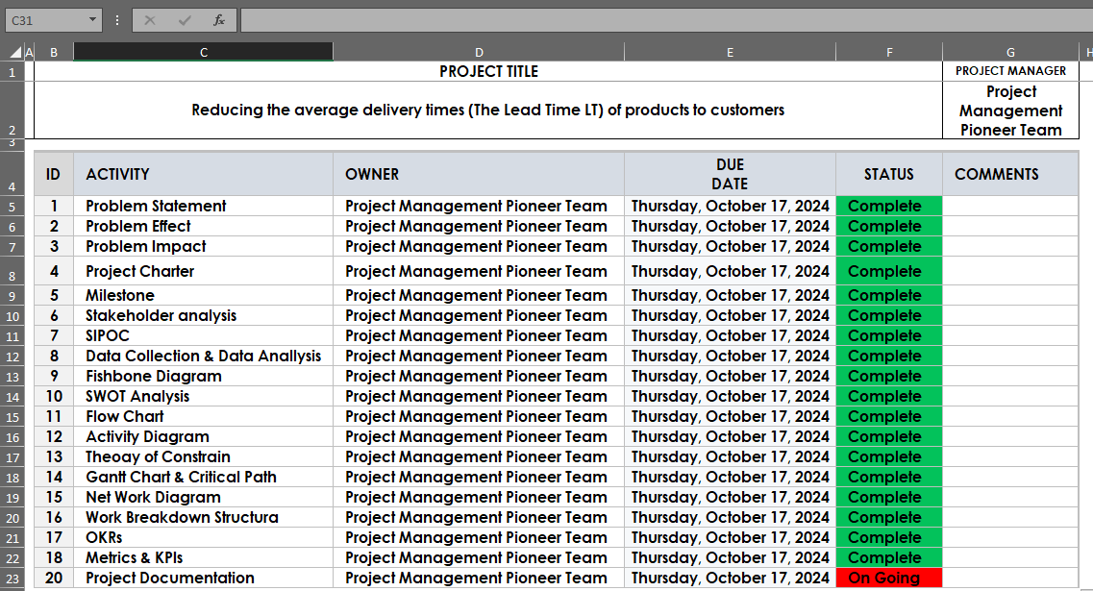

**Thank You**

**Project Management Pioneers team**